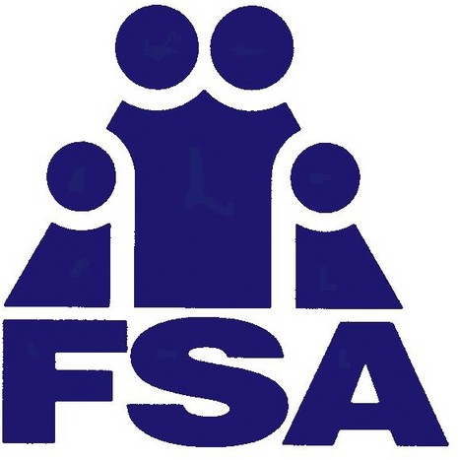**DOMESTIC VIOLENCE AND SEXUAL ASSAULT PROGRAM**

EMERGENCY SHELTER, 24/7 CRISIS LINE, CASE MANAGEMENT, SUPPORT GROUPS, RENTAL ASSISTANCE

Crisis line (877)482-4222 • 618 S Main St, Kokomo, IN 46901

MISSION

Goal: to reduce the incidence of domestic abuse and interpersonal violence in the counties we serve by providing:

Direct Services...to reach victims experiencing abuse and help them

break the cycle of violence through providing shelter, educational programming, and linkage to other community services.

Education...to educate the community, specialized groups, and victims

draw attention to the cycle of violence and abuse and the ways to protect oneself from others.

Prevention...to help prevent dating violence and all forms of

interpersonal abuse by informing adolescents, adults of all ages, and families of ways to relate that are wholesome and violence-free.

Consultation...to provide education and expertise on issues related to

domestic abuse to agencies, organizations, and peer institutions.

## CORE VALUES

Domestic Violence is a social epidemic that touches the lives of all ages, races, religions, educational backgrounds, and socioeconomic statuses.

Family Service Association of Howard County, Inc. Domestic Violence and Sexual Assault Programs exist because we believe that love should not hurt and that everyone deserves a safe home.

Our programs are designed to optimize these values: Empowerment of survivors

Safety of all residents, staff and visitors Equality

Respect for self and others

Confidentiality of information within the community.

# Family Service Association of Howard County, Inc.

**Domestic Violence & Sexual Assault Program January 1, 2023 - December 31, 2023**



### Number of Adults Served: **369**

Number of Children Served: **140**

Total Number of Shelter Days Provided: **5,387**

Number of Meals Provided: **16,161**

### Age Range of Clients Served: **0-64**

Total Number of Non-Residents Receiving Services: **72**

Rapid Rehousing:

Number of Adults Served: 18

Number of Children: 26

Total Number of Crisis Calls: **376**

Total Number of I & R Calls: **1,586**

Total Number of Advocacy Related Services: **4,959**

Sexual Assault Assistance: **34**

Protective Order Assistance: **6**

Help support the Domestic Violence and Sexual Assault Program by contacting Family Service Association of Howard County, Inc.

765-868-3154 or 877-482-4222

fsahc.org



